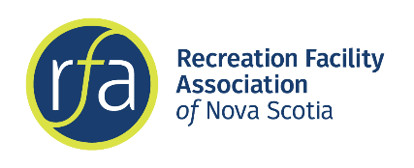
Recreation Facility Association of Nova Scotia

Position: Administrative Assistant (Summer position)
Published: Wednesday, May 4th, 2022

The Recreation Facility Association of Nova Scotia (RFA NS) is a not-for-profit organization dedicated to providing leadership in developing, promoting and advocating excellence in recreational facilities, operations and personnel. RFA NS strives to be the industry resource for coursing, training and educational resources for Nova Scotia’s recreation facilities.

RFA NS is seeking a motivated individual to serve as the summer Administrative Assistant.

Duties and Responsibilities
- Administration work such as responding to inquires by phone, email or in person, filing, mailouts, formatting documents, tracking inventory, etc.
- Maintain regular website and social media updates
- Communicate with members through monthly emails concerning upcoming events, training, and relevant information to our industry
- Update and develop recreation facilities list for Nova Scotia
- Research trends, training opportunities and current issues
- Develop promotional, marketing and sponsorship material for events and training as needed
- Helping with research projects and other opportunities for training due to COVID restrictions.
- Assist Executive Director in day-to-day operations of the Association.
- Other projects as assigned by the Executive Director.

Qualifications
- Highly self motivated with excellent communication and interpersonal skills
- Well organized, ability to multi-task, prioritize and work independently
- Experience using social media, updating websites and marketing knowledge
- Proficient computer skills (Word, Excel, Publisher, Internet, WordPress etc.)
- Ability to work some flexible hours. May be required to work remotely.
- Must be between 15 – 30 years of age.

This position may require some travel within Nova Scotia so access to reliable transportation would be considered an asset.

Job Term – May 30th, 2022 - July 29th, 2022 (8 weeks)
Salary - $14.00 per hour for 35 hours a week
Location - Halifax, Nova Scotia

Deadline – Friday, May 20th, 2022 at 5:00 pm. To apply please send your cover letter and resume to rfans@sportnovascotia.ca with “Summer Job Application” in the subject line.

